
Real Estate Market Trend Analysis using GitHub, AWS S3, Snowflake, and Power BI
Presented by : Ranit Karmakar
Univ. Roll No.: 13030523041
Department : CSE(DS)
Institution : Techno Main Salt lake
Contact : karmakarranit2312@gmail.com

Abstract
This project focuses on analyzing real estate market trends using modern cloud-based data engineering and business intelligence tools. The main objective of the project is to collect, store, process, analyze, and visualize housing market data in an interactive way.
Three datasets related to the housing market were used in this project:
- Secondary market property listings
- Rental property listings
- District-wise monthly housing price trends
The project workflow begins with uploading the datasets into GitHub using command prompt. After that, the datasets are uploaded into AWS S3 cloud storage. Snowflake is then connected with AWS S3 to extract and load the data into cloud tables. SQL queries are written in Snowflake for data analysis and business insights. The query outputs are downloaded and imported into Power BI for dashboard creation.
The Power BI dashboard provides interactive visualizations such as trend analysis, rental analysis, mortgage analysis, district-wise comparison, seller analysis, and metro-distance analysis. Different slicers and KPI cards are used to make the dashboard dynamic and user-friendly.
This project demonstrates the complete workflow of cloud-based data analytics using GitHub, AWS S3, Snowflake, SQL, and Power BI.

Contents
Abstract 2
Introduction 4
Motivation 5
Project Objectives 6
Dataset Description 6
Workflow 9
System Architecture 11
Software Requirement Specification (SRS) 11
SDK (Software Development Kit) 15
Software Development Life Cycle (SDLC) 15
Feasibility Study 17
Database Design 18
Source Code 19
System Requirements 31
Future Scope 32
Conclusion 34

Introduction
The real estate industry is one of the most important sectors in every country. Housing prices, rental prices, mortgage rates, and property demand change regularly based on economic conditions, population growth, and infrastructure development.Real estate companies, investors, banks, and government organizations need proper data analysis to understand market conditions and make better decisions.
Traditional methods of analyzing real estate data are slow and difficult because the amount of data is very large. Modern cloud technologies and business intelligence tools help solve this problem by processing and visualizing large datasets efficiently.This project was developed to analyze real estate market trends using cloud-based technologies and interactive dashboards.
The project uses:
- GitHub for version control and dataset management
- AWS S3 for cloud storage
- Snowflake for cloud data warehousing
- SQL for data analysis
- Power BI for visualization and dashboard creation
The dashboard helps users understand:
- Average property prices
- Average monthly rents
- Mortgage rate trends
- District-wise property distribution
- Seller analysis
- Metro-distance impact on prices
- Building type analysis
- Market trends over time
This project provides practical experience in data engineering, SQL analytics, cloud storage, and business intelligence.

Motivation
The main motivation behind this project is to understand how cloud-based technologies can be used to analyze large-scale real estate data efficiently.
The project was created to achieve the following goals:
- Learn modern data engineering workflow
- Understand cloud storage and cloud data warehouses
- Practice SQL queries using real datasets
- Create interactive business dashboards
- Analyze real estate market trends
- Gain practical knowledge of Snowflake and Power BI
Real estate data contains large amounts of information such as:
- Property prices
- Rental prices
- Building information
- Mortgage rates
- Seller details
- Metro accessibility
- District-level trends
Analyzing this data manually is very difficult. Therefore, cloud tools and business intelligence platforms are necessary.
Another motivation behind this project was to create an industry-style analytics pipeline. The project follows the same workflow used in many modern companies:
GitHub → AWS S3 → Snowflake → SQL Analysis → Power BI Dashboard
The project also improves understanding of:
- Cloud integration
- Database management
- Data visualization
- SQL optimization
- Business analytics

Project Objectives
The major objectives of the project are:
- To upload datasets into GitHub using command prompt.
- To store datasets in AWS S3 cloud storage.
- To connect Snowflake with AWS S3.
- To create cloud tables in Snowflake.
- To perform SQL analysis on housing market data.
- To generate analytical output tables.
- To import processed data into Power BI.
- To build an interactive dashboard.
- To analyze housing market trends and insights.
- To understand complete end-to-end data analytics workflow.

Dataset Description
Three datasets were used in this project.

1. district_prices_monthly.csv
This dataset contains monthly aggregated real estate market trends by district.
Column Name | Meaning
year_month | Month and year of the record (example: 2024-01)
district | Name of the district/locality
okrug | Administrative region/zone containing districts
secondary_price_per_sqm | Average resale property price per square meter
newbuild_price_per_sqm | Average new construction property price per square meter
rental_price_per_sqm_monthly | Average monthly rental price per square meter
secondary_mom_change_pct | Month-over-month percentage change in secondary market prices
newbuild_mom_change_pct | Month-over-month percentage change in new-build prices
n_listings_secondary | Number of resale property listings
n_listings_newbuild | Number of newly built property listings
n_listings_rental | Number of rental listings
cbr_key_rate_pct | Central Bank interest/key rate percentage
avg_mortgage_rate_pct | Average home loan (mortgage) interest rate

2. rentals.csv
This dataset contains individual rental property listings.
Column Name | Meaning
id | Unique rental listing ID
date_posted | Date when property was listed
district | District/locality of property
okrug | Administrative zone
lat | Latitude coordinate
lon | Longitude coordinate
total_area | Total area of apartment/property in square meters
rooms | Number of rooms
floor | Floor number of apartment
total_floors | Total floors in the building
building_year | Year building was constructed
building_type | Type of building (panel, brick, monolith, etc.)
renovation | Renovation condition/type
furnished | Whether furniture is available (True/False)
pets_allowed | Whether pets are allowed
deposit_months | Number of months required as security deposit
metro_station | Nearest metro/subway station
metro_line | Metro line name
metro_distance_min | Time in minutes to reach metro station
to_center_km | Distance from city center in kilometers
monthly_rent_rub | Monthly rent amount in Russian Rubles
rent_per_sqm | Rent per square meter

3. secondary_market.csv
This dataset contains individual resale property listings.
Column Name | Meaning
id | Unique property listing ID
date_posted | Listing date
district | District/locality
okrug | Administrative zone
lat | Latitude coordinate
lon | Longitude coordinate
total_area | Total property area
living_area | Living room area
kitchen_area | Kitchen area
rooms | Number of rooms
floor | Floor where property is located
total_floors | Total floors in building
building_year | Construction year
building_type | Building material/type
ceiling_height | Ceiling height in meters
has_balcony | Whether balcony exists
renovation | Renovation quality
metro_station | Nearest metro station
metro_line | Metro line
metro_distance_min | Minutes to metro station
metro_distance_type | Method of reaching metro (walk/transport)
to_center_km | Distance to city center
price_rub | Total property price in Rubles
price_per_sqm | Price per square meter
mortgage_rate_at_listing | Mortgage rate when listed
seller_type | Seller category (owner, agency, developer, etc.)

Workflow
The workflow of the project follows a cloud-based data engineering pipeline.
Step 1: Dataset Collection
The datasets were collected from Kaggle and stored in CSV format.
Step 2: Upload to GitHub
The datasets were uploaded into GitHub repository using command prompt.
Git commands used:
git init
git add .
git commit -m "Dataset Upload"
git branch -M main
git remote add origin <repository_link>
git push -u origin main
Step 3: Upload to AWS S3
The CSV files were uploaded into AWS S3 bucket.
Purpose:
- Cloud storage
- Secure file management
- Integration with Snowflake
Step 4: Create Snowflake Tables
Snowflake tables were created for all three datasets.
Step 5: Data Loading
Snowflake stage was connected with AWS S3.
COPY INTO command was used to load the data.
Step 6: SQL Analysis
SQL queries were written for:
- KPI calculations
- Trend analysis
- Seller analysis
- Rental analysis
- Mortgage analysis
- District comparison
Step 7: Download Query Outputs
The SQL output tables were downloaded from Snowflake.
Step 8: Power BI Visualization
The output tables were imported into Power BI.
Interactive visualizations, KPI cards, and slicers were created.
Step 9: Dashboard Creation
An interactive dashboard was developed for business analysis.

System Architecture
The architecture of the project is shown below:
Datasets
↓
GitHub Repository
↓
AWS S3 Storage
↓
Snowflake Data Warehouse
↓
SQL Analysis
↓
Export Output Tables
↓
Power BI Dashboard

Software Requirement Specification (SRS)
1. Introduction
This project is developed to analyze real estate market trends using cloud-based technologies and business intelligence tools.
The project uses:
- GitHub for repository management
- AWS S3 for cloud storage
- Snowflake for data warehousing
- SQL for data analysis
- Power BI for dashboard visualization
The system helps analyze:
- property prices
- rental trends
- mortgage rates
- district-wise housing analysis

2. Objectives
The main objectives of the project are:
- Upload datasets into GitHub and AWS S3.
- Store and manage data in Snowflake.
- Perform SQL-based analysis.
- Generate business insights.
- Create an interactive Power BI dashboard.

3. Functional Requirements
The system should be able to:
- Upload datasets to AWS S3
- Connect Snowflake with S3
- Create Snowflake tables
- Execute SQL queries
- Generate KPI values
- Create charts and visualizations
- Apply slicers and filters in Power BI

4. Non-Functional Requirements
- System should be user-friendly
- Dashboard should be interactive
- SQL queries should run efficiently
- Data should be accurate and secure

5. System Requirements
Hardware Requirements
Component | Requirement
Processor | Intel i3 or above
RAM | Minimum 4 GB
Storage | 10 GB free space
Internet | Stable connection

Software Requirements
Software | Purpose
GitHub | Repository management
AWS S3 | Cloud storage
Snowflake | Data warehouse
SQL | Data analysis
Power BI Desktop | Visualization

6. Datasets Used
- district_prices_monthly.csv
- rentals.csv
- secondary_market.csv
These datasets contain:
- property prices
- rental information
- mortgage rates
- building details
- district-wise trends

7. Output of the System
The system generates:
- SQL output tables
- KPI metrics
- Interactive Power BI dashboard
- Real estate market insights

8. Advantages of the System
- Cloud-based architecture
- Interactive dashboard
- Easy data analysis
- Better business insights
- Scalable system

9. Limitations
- Uses static datasets
- No real-time data integration
- Manual query execution required

10. Conclusion
The project successfully creates a cloud-based real estate analytics system using GitHub, AWS S3, Snowflake, SQL, and Power BI.
The system provides interactive analysis of:
- housing prices
- rental trends
- mortgage rates
- district-wise market performance
and helps users understand real estate market behavior efficiently.

SDK (Software Development Kit)
The following tools and technologies were used:
Tool | Purpose
GitHub | Version control and repository management
AWS S3 | Cloud storage
Snowflake | Cloud data warehouse
SQL | Data analysis
Power BI | Dashboard visualization
SDT (Software Development Tools)
Tool | Usage
Command Prompt | Git commands
Snowflake SQL Worksheet | Query execution
Power BI Desktop | Dashboard creation
AWS Console | Cloud file upload

Software Development Life Cycle (SDLC)
The project followed a structured Software Development Life Cycle (SDLC) approach to ensure proper planning, development, testing, and implementation.

1. Requirement Analysis
The project requirements were identified, including:
- cloud-based data storage
- SQL analytics
- interactive dashboard creation
- real estate market analysis

2. Planning
The technologies and workflow were selected for the project.
Tools used:
- GitHub
- AWS S3
- Snowflake
- Power BI
The complete workflow and dashboard structure were planned before development.

3. System Design
The database schema, Snowflake tables, SQL queries, and Power BI dashboard layout were designed.
Relationships between datasets and visualization requirements were also finalized.

4. Development
The development phase included:
- uploading datasets to GitHub and AWS S3
- creating Snowflake tables
- loading datasets into Snowflake
- writing SQL queries
- building the Power BI dashboard

5. Testing
The system was tested to ensure:
- successful data loading
- accurate SQL query results
- proper dashboard interaction
- correct slicer and visualization functionality

6. Deployment
The final dashboard and analytical outputs were prepared for presentation and reporting purposes.

7. Maintenance
The system can be updated in future by:
- adding new datasets
- integrating real-time APIs
- implementing machine learning models
- enhancing dashboard features

Feasibility Study
Feasibility study determines whether the project is practical and achievable.

1. Technical Feasibility
The project is technically feasible because:
- Snowflake supports cloud analytics.
- AWS S3 supports scalable storage.
- Power BI supports advanced visualization.
- SQL supports efficient querying.
2. Operational Feasibility
The system is easy to operate.
Users can:
- filter dashboards
- analyze trends
- view KPIs
- interact with charts
3. Economic Feasibility
The project is cost-effective because:
- educational/free versions of tools were used
- cloud resources were optimized
- no expensive infrastructure was needed
4. Schedule Feasibility
The project can be completed within the planned timeline.

Database Design
Three tables were created in Snowflake.
Table 1: district_prices_monthly : Stores monthly market trend data.
Important fields:
- district
- year_month
- mortgage rates
- listing counts
- rental price
- resale price
Table 2: rentals : Stores rental listing information.
Important fields:
- furnished
- monthly rent
- building type
- metro distance
Table 3: secondary_market : Stores resale property data.
Important fields:
- property price
- seller type
- building type
- mortgage rate
- renovation

Source Code
--Creation of database
create database fsp_project;
use fsp_project;
--creation of tables
CREATE OR REPLACE TABLE district_prices_monthly (
year_month STRING,district STRING,okrug STRING,secondary_price_per_sqm INTEGER,
newbuild_price_per_sqm INTEGER,rental_price_per_sqm_monthly INTEGER,
secondary_mom_change_pct FLOAT,newbuild_mom_change_pct FLOAT,
n_listings_secondary INTEGER,n_listings_newbuild INTEGER,n_listings_rental INTEGER,
cbr_key_rate_pct FLOAT,avg_mortgage_rate_pct FLOAT
);
CREATE OR REPLACE TABLE rentals (
id STRING,date_posted DATE, district STRING,okrug STRING, lat FLOAT,lon FLOAT,
total_area FLOAT, rooms INTEGER,floor INTEGER,total_floors INTEGER,
building_year INTEGER, building_type STRING,renovation STRING, furnished BOOLEAN,
pets_allowed BOOLEAN, deposit_months INTEGER, metro_station STRING,
metro_line STRING,metro_distance_min INTEGER, to_center_km FLOAT,
monthly_rent_rub INTEGER,rent_per_sqm INTEGER
);
CREATE OR REPLACE TABLE secondary_market (
id STRING,date_posted DATE, district STRING,okrug STRING, lat FLOAT,lon FLOAT,
total_area FLOAT,living_area FLOAT,kitchen_area FLOAT, rooms INTEGER,
floor INTEGER,total_floors INTEGER, building_year INTEGER, building_type STRING,
ceiling_height FLOAT, has_balcony BOOLEAN, renovation STRING, metro_station STRING,
metro_line STRING,metro_distance_min INTEGER,metro_distance_type STRING,
to_center_km FLOAT, price_rub INTEGER,price_per_sqm INTEGER,
mortgage_rate_at_listing FLOAT, seller_type STRING
);

--Creation of stage
create stage tmslstage
url='s3://fsp-project-bucket'
credentials=(
AWS_KEY_ID='******************'
AWS_SECRET_KEY=’ ************************************’
)
FILE_FORMAT = (TYPE = CSV);

LIST @tmslstage;
-- copy the tables into the database
copy into district_prices_monthly
from @tmslstage/district_prices_monthly.csv
file_format = (type =csv skip_header = 1);

COPY INTO rentals
FROM @tmslstage/rentals.csv
FILE_FORMAT = (TYPE = CSV SKIP_HEADER = 1);

COPY INTO secondary_market
FROM @tmslstage/secondary_market.csv
FILE_FORMAT = (TYPE = CSV SKIP_HEADER = 1);

-- 1. What is the overall average property price by district and okrug?
SELECT district, okrug,
ROUND(AVG(price_rub),2) AS avg_property_price
FROM secondary_market GROUP BY district, okrug
ORDER BY avg_property_price DESC;
Output: https://drive.google.com/file/d/1rl-7MWU8ugZrl3YXxL_8lowyd95C1IQ/view?usp=sharing
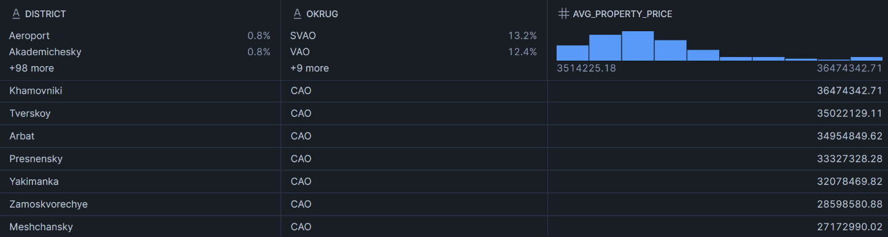
--2. What is the average monthly rent by district and furnishing status?
SELECT district,furnished,
ROUND(AVG(monthly_rent_rub),2) AS avg_monthly_rent
FROM rentals GROUP BY district, furnished
ORDER BY avg_monthly_rent DESC;
Output: https://drive.google.com/file/d/1kZUVnRixmBIrypBflNYkcsYSj8TWywbY/view?usp=drive_link
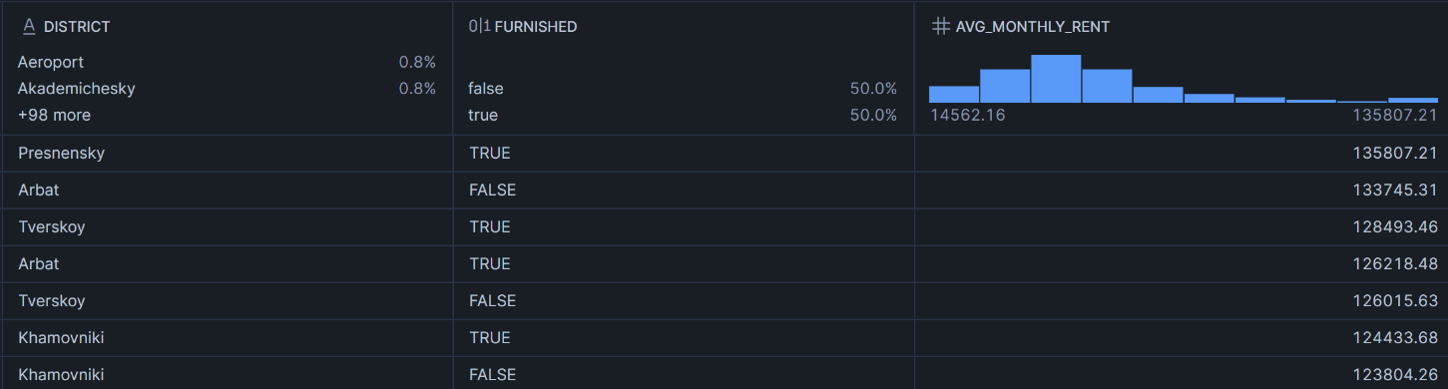
-- 3. How many total listings exist across districts and property categories?
SELECT district,SUM(n_listings_secondary) AS total_secondary_listings,
SUM(n_listings_newbuild) AS total_newbuild_listings, SUM(n_listings_rental) AS total_rental_listings
FROM district_prices_monthly GROUP BY district
ORDER BY total_secondary_listings DESC;
Output: https://drive.google.com/file/d/148HR4gwMZ6mDhS4FH62sMwY5ZYC9a8NE/view?usp=drive_link
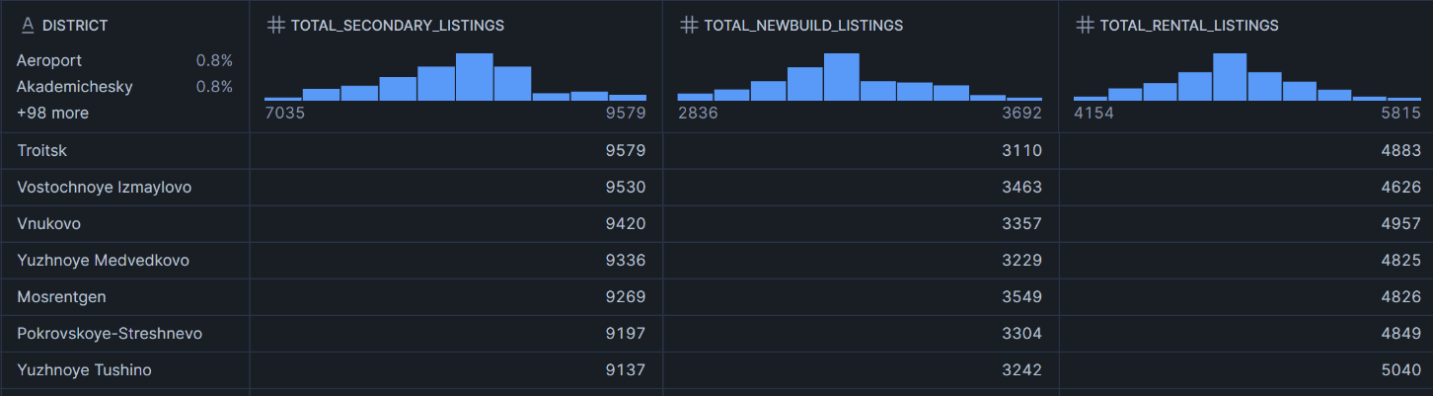-- 4. Which TOP 5 districts have the highest resale prices by building type?
SELECT district,building_type,
ROUND(AVG(price_per_sqm),2) AS avg_price_per_sqm
FROM secondary_market GROUP BY district, building_type
ORDER BY avg_price_per_sqm DESC LIMIT 5;
Output: https://drive.google.com/file/d/1TsNA14jQ9jiFDLOssubZCaPjI7EQ0OD1/view?usp=drive_link
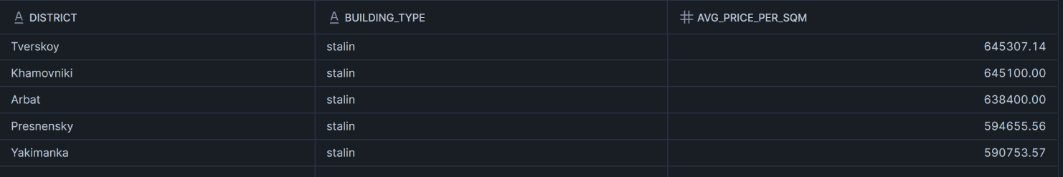
-- 5. How does rental price vary with metro distance?
SELECT district,furnished,
ROUND(AVG(metro_distance_min),2) AS average_metro_distance,
ROUND(AVG(monthly_rent_rub),2) AS avg_rent
FROM rentals GROUP BY district, furnished
ORDER BY average_metro_distance;
Output: https://drive.google.com/file/d/1cem5xqS3Mtrdvyqec2AwM8aaovnLupEF/view?usp=drive_link
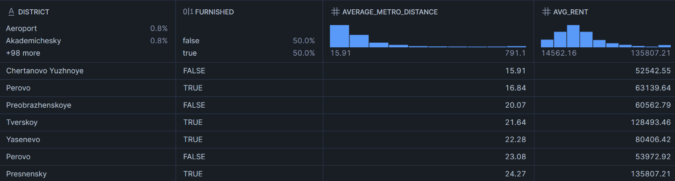
-- 6. Which renovation types command the highest property prices?
SELECT building_type,renovation,rooms,
ROUND(AVG(price_rub),2) AS avg_property_price
FROM secondary_market GROUP BY building_type, renovation, rooms
ORDER BY avg_property_price DESC;
Output: https://drive.google.com/file/d/1dtGJPertEd2hlKoL9JqBCpxOJaw13WZl/view?usp=drive_link
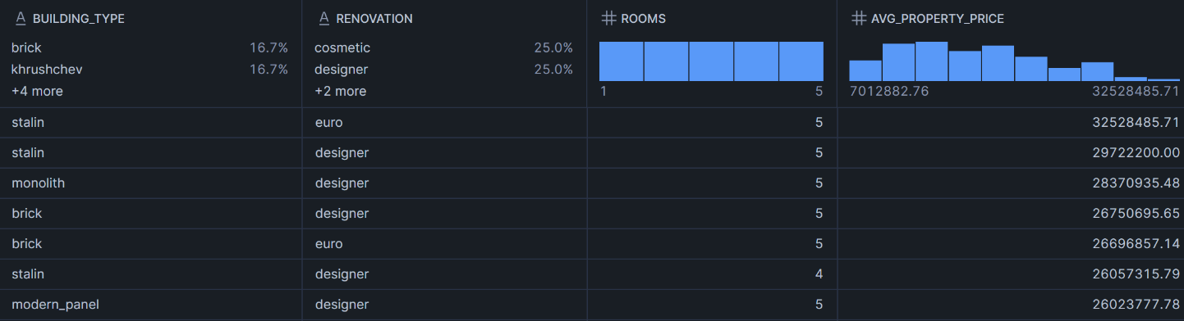
-- 7. What are the monthly trends of resale prices, rental prices, and mortgage rates?
SELECT year_month,district,okrug,secondary_price_per_sqm,rental_price_per_sqm_monthly,
avg_mortgage_rate_pct FROM district_prices_monthly
ORDER BY year_month;
Output: https://drive.google.com/file/d/1hVw9NxaiFf_QHm56PfbOkGoU1Jaw2yJS/view?usp=drive_link
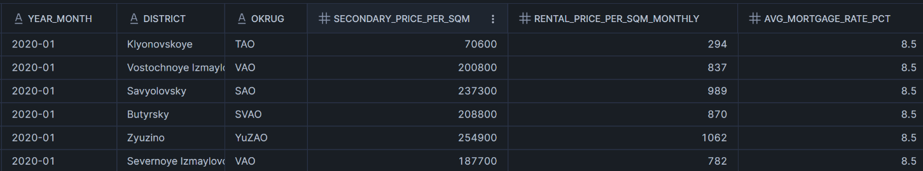
-- 8. Which seller types dominate different districts?
SELECT district,building_type,renovation,seller_type,COUNT(id) AS total_properties
FROM secondary_market GROUP BY district, building_type, renovation, seller_type
ORDER BY total_properties DESC;
Output: https://drive.google.com/file/d/1O4z51os8nNI8nRWrMSdGM2L5HGWVvE/view?usp=drive_link
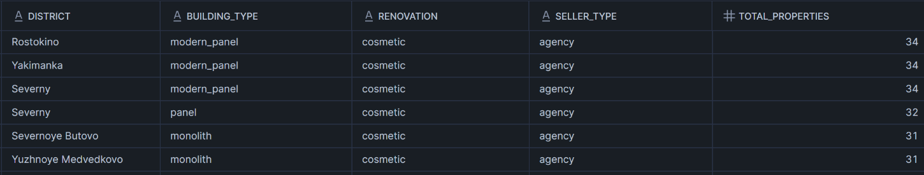
-- 9. How does distance from city center affect property prices?
SELECT district,building_type,rooms,to_center_km,
ROUND(AVG(price_per_sqm),2) AS avg_price_per_sqm
FROM secondary_market GROUP BY district, building_type, rooms, to_center_km
ORDER BY to_center_km;
Output: https://drive.google.com/file/d/1HJE9_T2hbllV8lUU6NWybHHfA_Min9Ns/view?usp=drive_link
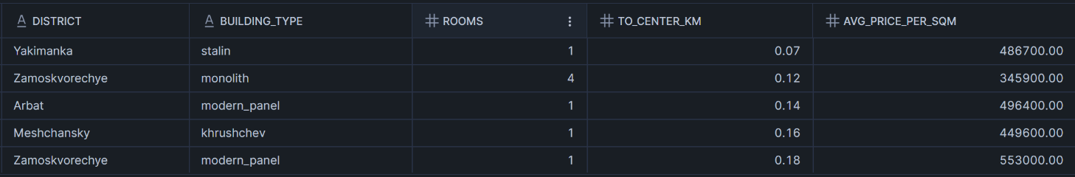
-- 10. Which districts have the highest rental and resale listing activity over time?
SELECT year_month,district,okrug,n_listings_secondary,n_listings_rental
FROM district_prices_monthly ORDER BY year_month;
Output: https://drive.google.com/file/d/1WdqJptaoEBAKXIJvtv6pK7DjcE0ZNZLh/view?usp=drive_link
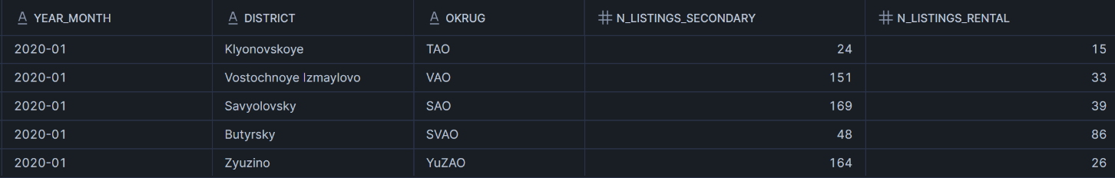
-- 11. Which districts have higher-than-average resale prices and rental prices simultaneously?
WITH resale_avg AS (
SELECT district,AVG(price_per_sqm) AS avg_resale_price FROM secondary_market GROUP BY district
),
rental_avg AS (
SELECT district,AVG(rent_per_sqm) AS avg_rent_price FROM rentals GROUP BY district
)
SELECT r.district,r.avg_resale_price,rt.avg_rent_price
FROM resale_avg r JOIN rental_avg rt ON r.district = rt.district
WHERE r.avg_resale_price >(SELECT AVG(price_per_sqm) FROM secondary_market)
AND rt.avg_rent_price >(SELECT AVG(rent_per_sqm) FROM rentals)
ORDER BY r.avg_resale_price DESC;
Output: https://drive.google.com/file/d/1PhlCcxuBnkCpaPRNoqscxaI62x2POEu/view?usp=drive_link
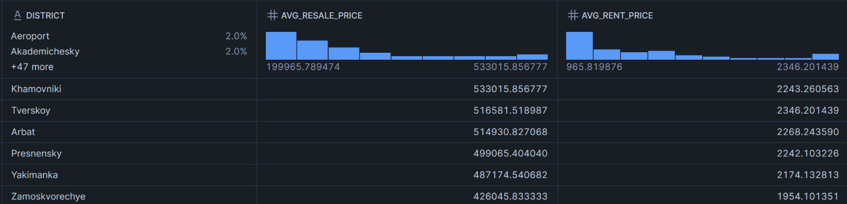
-- 12. Find districts where rental growth is high but listing activity is low.
WITH rental_growth AS (
SELECT district,AVG(rental_price_per_sqm_monthly) AS avg_rent
FROM district_prices_monthly GROUP BY district
),
listing_activity AS (
SELECT district,AVG(n_listings_rental) AS avg_rental_listings
FROM district_prices_monthly GROUP BY district
)
SELECT
rg.district,rg.avg_rent,la.avg_rental_listings
FROM rental_growth rg JOIN listing_activity la ON rg.district = la.district
WHERE la.avg_rental_listings <(SELECT AVG(n_listings_rental) FROM district_prices_monthly)
ORDER BY rg.avg_rent DESC;
Output: https://drive.google.com/file/d/1_2Bnh3PUnslMnjKt_zBRARjFYuk7oAYD/view?usp=drive_link
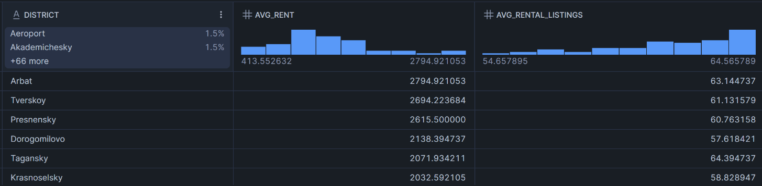

-- 13. Which seller types list properties farthest from the city center?
WITH seller_distance AS (
SELECT seller_type,district,AVG(to_center_km) AS avg_distance
FROM secondary_market GROUP BY seller_type, district
)
SELECT seller_type,district,avg_distance,
RANK() OVER(PARTITION BY seller_type ORDER BY avg_distance DESC) AS distance_rank
FROM seller_distance;
Output: https://drive.google.com/file/d/1WUzVwxE44hUAYTPXPDMcbKopDZGbXr0u/view?usp=drive_link
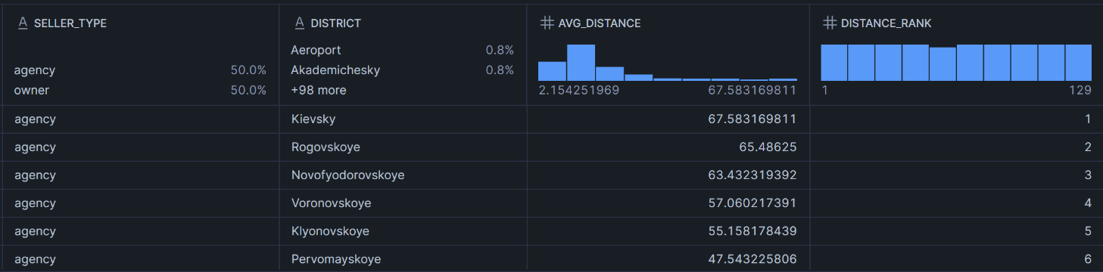
-- 14. Compare average resale price and rental price district-wise.
WITH resale_data AS (
SELECT district,AVG(price_per_sqm) AS avg_resale_price
FROM secondary_market GROUP BY district
),
rental_data AS (
SELECT district,AVG(rent_per_sqm) AS avg_rent_price FROM rentals GROUP BY district
)
SELECT r.district,r.avg_resale_price,rt.avg_rent_price FROM resale_data r
INNER JOIN rental_data rt ON r.district = rt.district ORDER BY r.avg_resale_price DESC;
Output: https://drive.google.com/file/d/1owEbaeYjKmnfKzNTOZPu5zgjMrdcONer/view?usp=drive_link
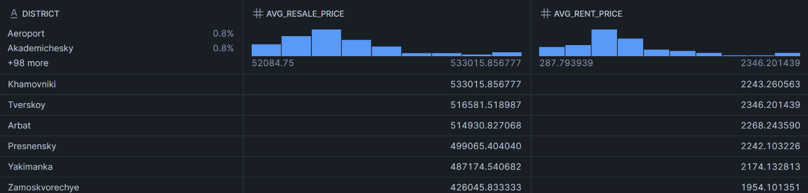
-- 15. Find districts where mortgage rates are above average but resale demand is still high.
WITH mortgage_data AS (
SELECT district,AVG(avg_mortgage_rate_pct) AS avg_mortgage_rate
FROM district_prices_monthly GROUP BY district
),resale_demand AS (
SELECT district,AVG(n_listings_secondary) AS avg_secondary_listings
FROM district_prices_monthly GROUP BY district
)SELECT m.district,m.avg_mortgage_rate,r.avg_secondary_listings FROM mortgage_data m
JOIN resale_demand r ON m.district = r.district
WHERE m.avg_mortgage_rate > (SELECT AVG(avg_mortgage_rate_pct)FROM district_prices_monthly) ORDER BY r.avg_secondary_listings DESC;
Output: https://drive.google.com/file/d/11oNBVFoxVWRkzz_eSiOnOqb2Ch5eOuR2/view?usp=drive_link
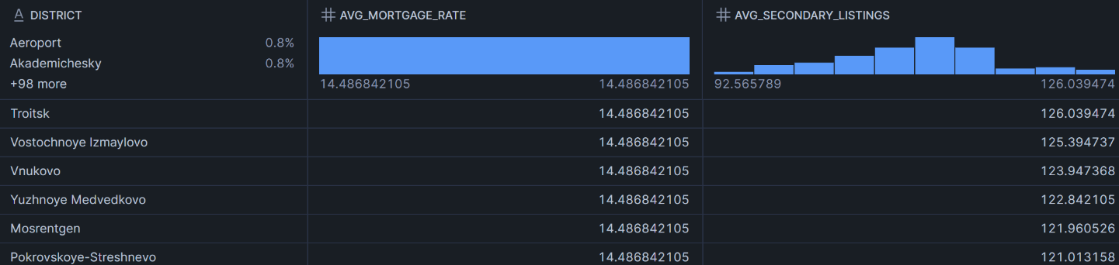
-- 16. Identify top 5 most expensive building types in each district.
WITH building_prices AS (
SELECT district,building_type,AVG(price_per_sqm) AS avg_price
FROM secondary_market GROUP BY district, building_type
)
SELECT district,building_type,avg_price,
DENSE_RANK() OVER(PARTITION BY district ORDER BY avg_price DESC) AS price_rank
FROM building_prices QUALIFY price_rank <= 5;
Output: https://drive.google.com/file/d/1Z78ozPa_vQvRMtdDqNR9t0rckuZwYiO/view?usp=drive_link
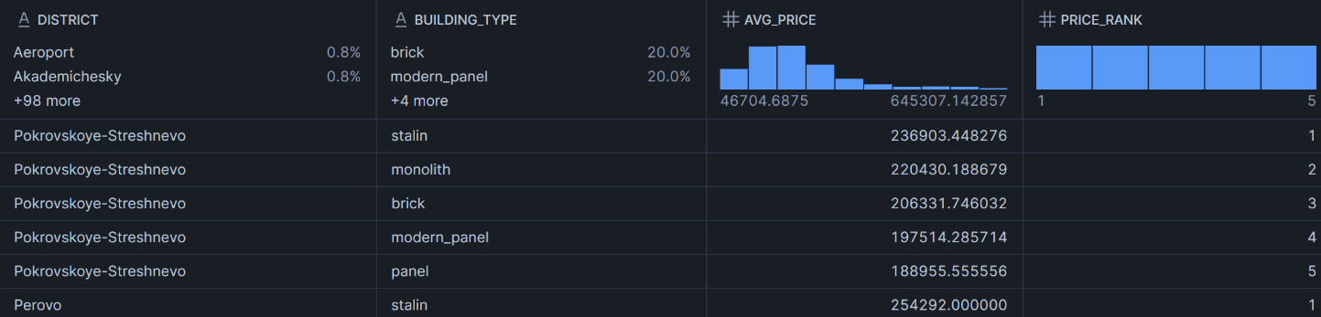
-- 17.Which districts have the best rental yield?
WITH resale_prices AS (
SELECT district,
AVG(price_rub) AS avg_property_price
FROM secondary_market GROUP BY district
),
rental_prices AS (
SELECT district,
AVG(monthly_rent_rub) AS avg_monthly_rent
FROM rentals GROUP BY district)
SELECT r.district,r.avg_property_price,rt.avg_monthly_rent,
ROUND(((rt.avg_monthly_rent * 12)/ r.avg_property_price) * 100,2) AS rental_yield_pct
FROM resale_prices r JOIN rental_prices rt ON r.district = rt.district
ORDER BY rental_yield_pct DESC;
Output: https://drive.google.com/file/d/1OumyINKXmXfJX1Z8KOoqTBPCADtBIi85/view?usp=drive_link
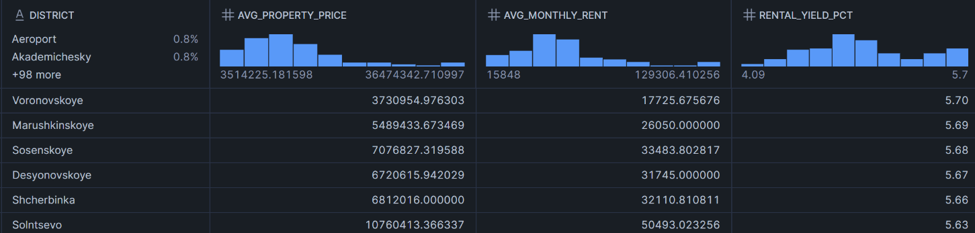

GitHub Repository: https://github.com/Ranit-2312/fsp-project-tmsl
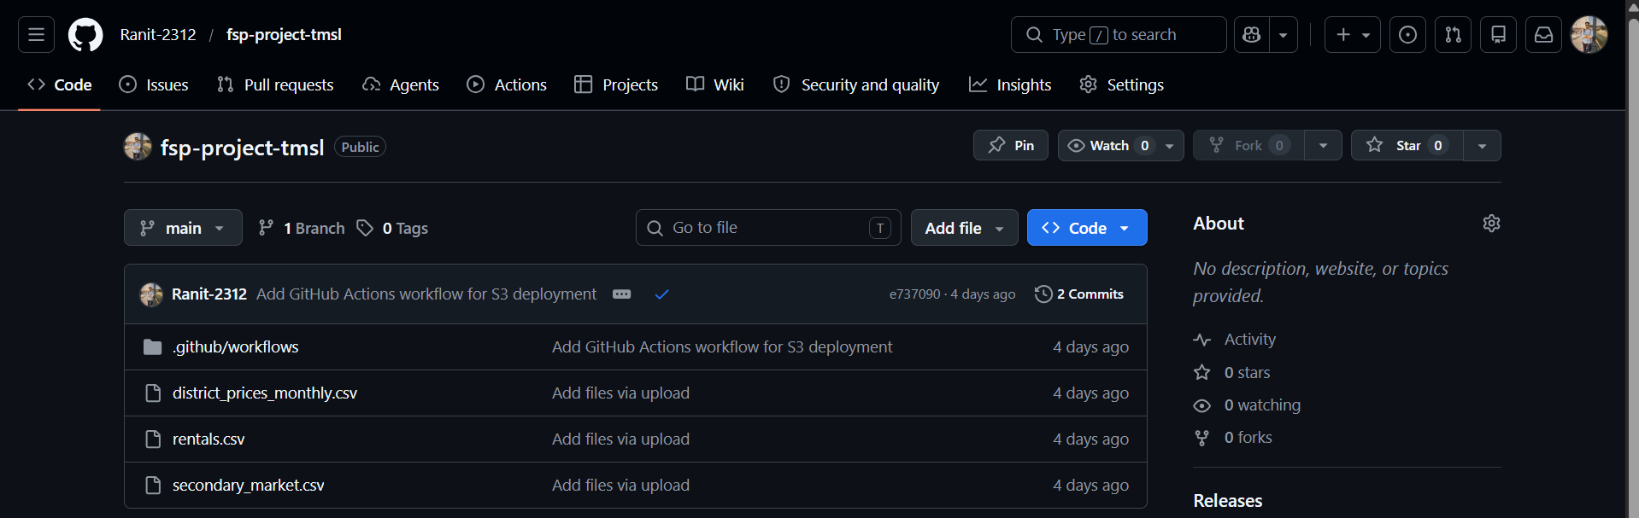
Snowflake Database:
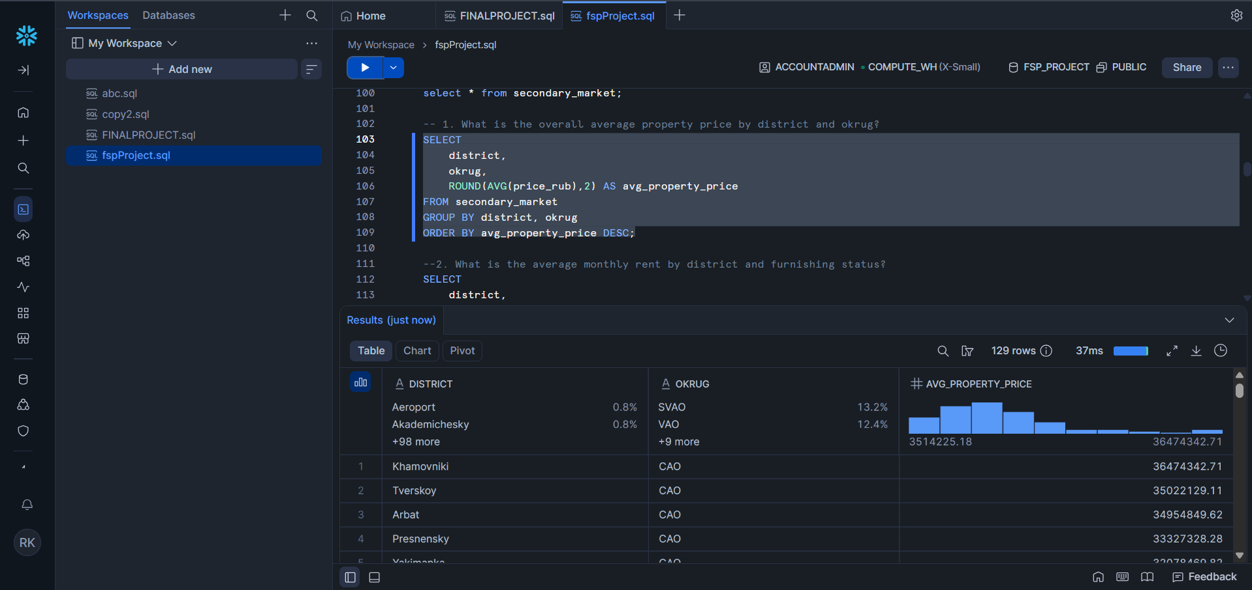
In this project, Snowflake was used as the cloud data warehouse for storing and analyzing real estate datasets. Tables were created for all datasets, and data was loaded from AWS S3 using a Snowflake stage. SQL queries were written to perform data analysis, calculate KPIs, generate trend reports, and create output tables. The processed query results were then exported and used in Power BI for interactive dashboard visualization.
Power BI Dashboard:
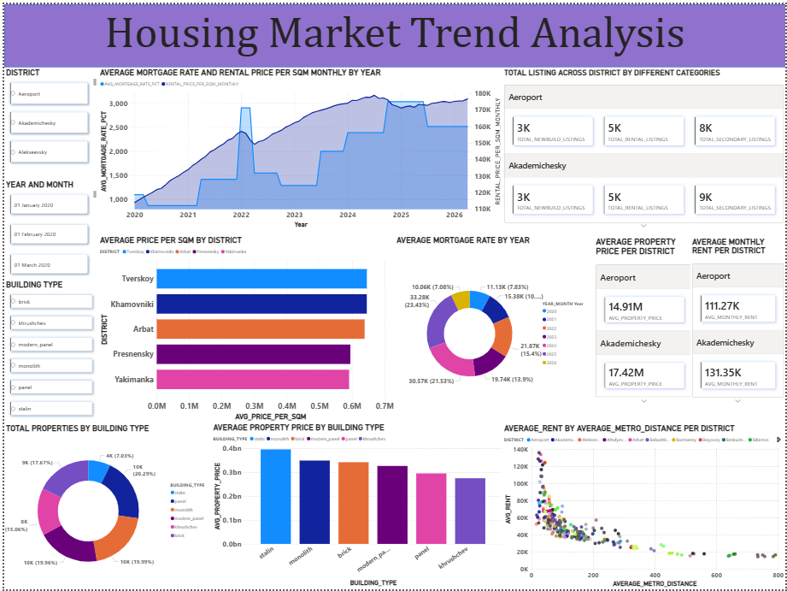
https://drive.google.com/file/d/100oXV_rBMyFAof27nLl0h1qkUpJR-wdh/view?usp=drive_link
The Power BI dashboard developed in this project provides an interactive and visual representation of real estate market trends. The dashboard was created using Microsoft Power BI after processing and analyzing the datasets in Snowflake.
The main purpose of the visualization is to convert complex housing market data into simple and understandable graphical insights. Different charts, KPI cards, and slicers were used to help users analyze the real estate market efficiently.
The dashboard focuses on important real estate factors such as:
- average property prices
- rental prices
- mortgage rates
- district-wise market comparison
- building type analysis
- metro-distance impact on rent
- listing distribution across districts
The dashboard is fully interactive. Users can apply slicers such as:
- district
- year and month
- building type
to dynamically filter and analyze the data.
Several visualizations were included in the dashboard, such as:
- line charts for trend analysis
- bar charts for district comparison
- donut charts for category distribution
- scatter plots for metro-distance analysis
- Cards for key business metrics
The dashboard helps users quickly identify:
- high-demand districts
- expensive property regions
- rental market patterns
- mortgage rate fluctuations
- building type performance
The visualization improves decision-making by presenting data in a clear, interactive, and user-friendly format. It also demonstrates how business intelligence tools can transform raw cloud-stored data into meaningful business insights.

System Requirements
Hardware Requirements
The following hardware components are required to run the project successfully:
Component | Requirement
Processor | Intel i3 / i5 / Ryzen Processor or above
RAM | Minimum 4 GB RAM
Storage | Minimum 10 GB free disk space
Internet Connection | Stable internet connection
Monitor Resolution | 1366 × 768 or higher

Software Requirements
The following software and tools were used in the project:
Software / Tool | Purpose
Windows 10/11 | Operating System
Git | Uploading files to GitHub
GitHub | Repository management
AWS S3 | Cloud storage
Snowflake | Cloud data warehouse
SQL | Data querying and analysis
Power BI Desktop | Dashboard creation and visualization
Web Browser | Accessing cloud platforms

Cloud Requirements
Cloud Service | Usage
AWS S3 Bucket | Dataset storage
Snowflake Stage | Data loading from S3
Snowflake Warehouse | Query execution
Power BI Service/Desktop | Interactive visualization

Future Scope
This project can be improved further by adding more advanced features and technologies in the future.
1. Real-Time Data Integration
Currently, static CSV datasets are used. In the future, live real estate APIs can be connected to provide real-time market updates.
2. Machine Learning Integration
Machine learning algorithms can be added for:
- Property price prediction
- Rental trend forecasting
- Investment recommendation
- Demand analysis
3. Advanced Dashboard Features
More advanced Power BI features can be implemented such as:
- AI visuals
- Natural language query support
- Advanced drill-through reports
- Dynamic forecasting charts
4. Geospatial Analysis
Map-based analytics can be improved using GIS tools and advanced location analysis.
- Heatmaps
- Property clustering
- Metro accessibility zones
5. Automated ETL Pipeline
Currently, the data upload process is semi-manual. In future:
- AWS Glue
- Apache Airflow
- Snowpipe
can be used to automate the ETL pipeline.
6. Mobile Dashboard Support
The dashboard can be optimized for mobile devices to improve accessibility for users.
7. Security Enhancements
Additional security features can be added such as:
- Role-based access control
- Data encryption
- Secure API integration
8. Expansion to Other Cities
The project can be expanded to analyze housing markets of multiple cities or countries.

Conclusion
This project successfully developed an end-to-end real estate analytics system using modern cloud technologies and business intelligence tools.
The project started with uploading datasets into GitHub and AWS S3 cloud storage. Snowflake was used as the cloud data warehouse for storing and analyzing the datasets using SQL queries. The processed outputs were then imported into Power BI to create an interactive dashboard.
The dashboard provides meaningful insights regarding:
- Property prices
- Rental market trends
- Mortgage rate analysis
- District-wise comparison
- Seller analysis
- Building type analysis
- Metro-distance impact
Different KPI cards, slicers, and visualizations were used to make the dashboard interactive and user-friendly.
The project also helped in understanding:
- Cloud storage systems
- Data warehousing
- SQL-based analytics
- Data visualization
- Business intelligence workflow
- End-to-end analytics pipeline
Overall, the project achieved all planned objectives successfully and demonstrated how cloud-based technologies can be integrated for solving real-world business analytics problems efficiently.
The project provides a strong foundation for future advanced analytics and machine learning-based real estate systems.

